Willow Primary Pupil Premium Strategy Statement

School overview
Detail | Data
School name | Willow Primary
Number of pupils in school | 34
Proportion (%) of pupil premium eligible pupils | 9%
Academic year/years that our current pupil premium strategy plan covers | 2023/25
Date this statement was published | September 2023
Date on which it will be reviewed | July 2024 and 2025
Statement authorised by | Davina Sumner
Pupil premium lead | Mike Parkinson
Governor / Trustee lead | Jonathan Moody
Funding overview
Detail | Amount
Pupil premium funding allocation this academic year | £49,470
Recovery premium funding allocation this academic year | £2,295
Pupil premium funding carried forward from previous years (enter £0 if not applicable) | £0
Total budget for this academic year  If your school is an academy in a trust that pools this funding, state the amount available to your school this academic year | £51,765

Part A: Pupil premium strategy plan

Statement of intent
Our intention is that all pupils, irrespective of their background or the challenges they face, make good progress and achieve high attainment across all subject areas. The focus of our pupil premium strategy is to support disadvantaged pupils to achieve that goal, including progress for those who are already high attainers.
We will consider the challenges faced by vulnerable pupils, such as those who have a social worker and young carers. The activity we have outlined in this statement is also intended to support their needs, regardless of whether they are disadvantaged or not.
High-quality teaching is at the heart of our approach, with a focus on areas in which disadvantaged pupils require the most support. This is proven to have the greatest impact on closing the disadvantage attainment gap and at the same time will benefit the non-disadvantaged pupils in our school. Implicit in the intended outcomes detailed below, is the intention that non-disadvantaged pupils’ attainment will be sustained and improved alongside progress for their disadvantaged peers.
Our strategy is also integral to wider school plans for education recovery, notably in its targeted support through the National Tutoring Programme for pupils whose education has been worst affected, including non-disadvantaged pupils.
Our approach will be responsive to common challenges and individual needs, rooted in robust diagnostic assessment, not assumptions about the impact of disadvantage. The approaches we have adopted complement each other to help pupils excel. To ensure they are effective we will:
• Ensure disadvantaged pupils are challenged in the work that they’re set
• Act early to intervene at the point need is identified
• Adopt a whole school approach in which all staff take responsibility for disadvantaged pupils’ outcomes and raise expectations of what they can achieve
Challenges

This details the key challenges to achievement that we have identified among our disadvantaged pupils.
Challenge number | Detail of challenge
1 | Disadvantaged children will have gaps in their learning and have suffered uncertainty during the Covid 19 crisis.
2 | Very few children eligible for pupil premium achieve at greater depth. In some year groups no children eligible for pupil premium are achieving greater depth.
3 | In most KS2 year groups a lower proportion of children eligible for PP are achieving ARE in reading and writing compared to children non-eligible for PP.
4 | Children eligible for pupil premium have lower attendance rates than other children.
5 | Parental support and engagement.

Intended outcomes
Intended outcome | Success criteria
Progress in Reading | Achieve national average progress  scores or above in KS1 and KS2 Reading
Progress in Writing | Maintain national average progress  scores or above in KS1 / KS2 Writing
Progress in Mathematics | Achieve national average progress scores in KS1/ KS2 Mathematics
Phonics | Achieve national average or above expected standard in PSC.
Other | Ensure attendance of disadvantaged pupils is above 95%.

Activity in this academic year

Teaching
Budgeted cost: £9,765
Activity | Evidence that supports this approach | Challenge number(s) addressed
CPD to enhance the standard of the teaching sequence in reading and writing. | Internal writing data showed that non-disadvantaged children outperform disadvantaged in all year groups last academic year.  EEF ‘Guide to Pupil Premium’ states that ‘Ensuring an effective teacher is given the required CPD to continue to improve has to be top of the list for Pupil premium spending’. | 1,2,3
Continue to develop the culture of speech, language and communication through the development of oracy skills. | 20 Most Effective Pupil Premium Strategies For Primary Schools’ states that oral language interventions can impact in early years (+7 months) and primary schools (+6 months) | 1,2,3
Staff CPD | High quality staff CPD is essential to follow EEF principles. This is then followed up during Staff meetings and INSET. We are part of the Doncaster OA writing project and the Yorkshire Maths Hub (Early Number).  All staff to lead effectively are released for relevant CPD. | 1,2,3,4,5
Purchase of standardised diagnostic assessments.  Training for staff to ensure assessments are interpreted and administered correctly. | Standardised tests can provide reliable insights into the specific strengths and weaknesses of each pupil to help ensure they receive the correct additional support through interventions or teacher instruction:  Standardised tests | Assessing and Monitoring Pupil Progress | Education Endowment Foundation | EEF | 1,2,3

Targeted academic support
Budgeted cost: £28,000
Activity | Evidence that supports this approach | Challenge number(s) addressed
-Continue to use small group interventions for disadvantaged pupils falling behind age-related  expectations.  -To push higher attaining ones to the greater depth standard. | EEF Toolkit states that small group tuition has an average impact of 4 months’ additional progress over the course of a year. | 1,2,3
Fund TA’s in each year group to run 1 to 1 and small group interventions in the afternoons. | 20 Most Effective Pupil Premium Strategies For Primary Schools states that ‘1 to 1 and small group interventions can add 5 months progress per academic year.’ | 1,2,3
-Use National Tutoring funding to provide 1 on 1 and small group catch up programme for disadvantaged pupils. | EEF ‘Guide to Pupil Premium’ states, evidence shows the positive impact targeted academic 1 to 1 or small group interventions. | 1,2,3
-Additional phonics sessions targeted at disadvantaged pupils who require further phonics support. | Phonics approaches have a strong evidence base indicating a positive impact on pupils, particularly from disadvantaged backgrounds. Targeted phonics interventions have been shown to be more effective when delivered as regular sessions over a period up to 12 weeks:  Phonics | Toolkit Strand | Education Endowment Foundation | EEF | 1,2,3

Wider strategies (for example, related to attendance, behaviour, wellbeing)
Budgeted cost: £14,000
Activity | Evidence that supports this approach | Challenge number(s) addressed
Inclusion manager to support disadvantaged learners with social and emotional support. | Third Space Learning – ‘20 Most Effective Pupil Premium Strategies For Primary Schools’ states that targeting social and emotional learning has been found to effective across all key stages and can 4+ months progress. | 1,2,3,4,5
Fund/part fund extra-curricular and curricular opportunities for disadvantaged pupils. | EEF Toolkit states that | 1,2,3

Total budgeted cost: £51,765

Part B: Review of outcomes in the previous academic year

Pupil premium strategy outcomes
Summary of Whole School Data
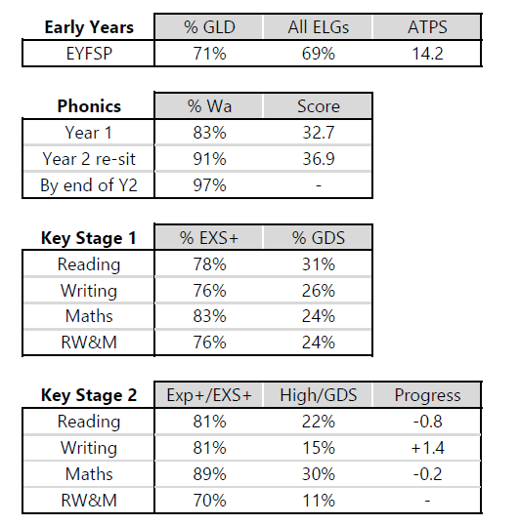

Summary of Pupil Premium Core Subject Achievements.
Reading:
-In year 3 and 4 100% of the PP children achieved expected.
-KS2 results show an upward trend rising from 65% in 2022 to 70% of children achieving the expected standard in 2023.
Writing:
In year 3 and 4 100% of the PP children achieved expected. Y4 moving from 50% in 2021.
In year 6, there is an upward trend in the expected standard. in 2022, 40% of PP children achieved the expected standard. In 2023, it was 60%.
-Progress in KS2 was + 1.1, an improvement from 2022.
Maths:
-In year 3 and 4 100% of the PP children achieved expected. Y4 moving from 25% in 2021.
-In Y6, the percentage of PP achieving Ex+ increased from 2022 to 2023 (Y6 32 to 90).
-In year 5, the percentage increased for GD pupils. Progress also increased from –3 in 2022 to +0.3 in 2023.
Combined:
In year 3 and 4 100% of the PP children achieved combined. Y4 moving from 25% in 2021.
In year 6, the percentage again shows an upward trend from 17% in 2022 to 60% in 2023.
GPS
Ks2 SATS results show an increase in the expected standard of 13 % from 2022 to 2023 (57% to 70%).

-The funding for tutoring was effectively used. Year 4 and 6 were targeted first. All PP pupils received it, with a focus on maths in both year groups. The data shows an increase in both year groups over the past two academic years (Y4 - 25% to 100% and Y6 – 71% to 90%).

